

**COMSATS University Islamabad**

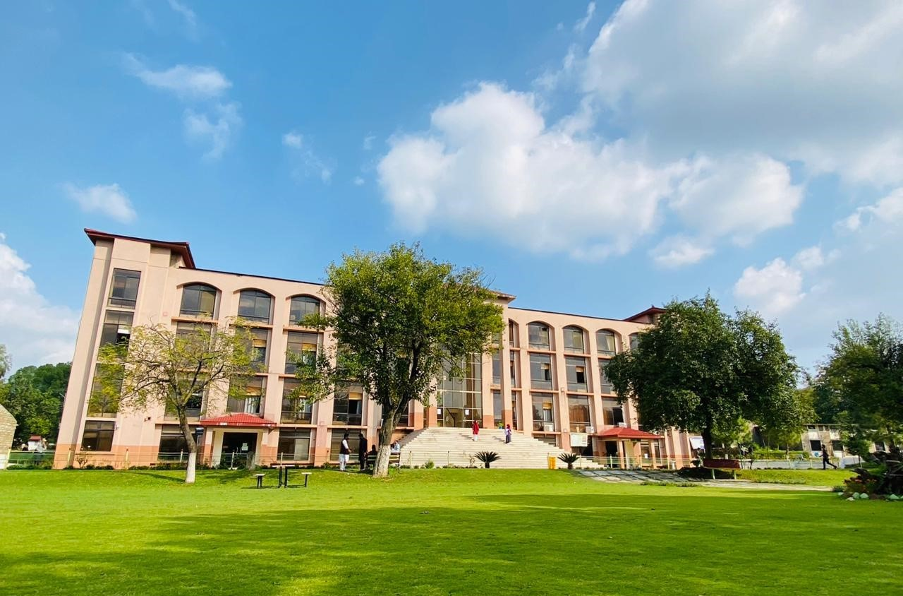 **(Abbottabad Campus)**

**NAME: FATIMA AFTAB**

**REGISTRATION NO: FA21-BSE-088**

**ASSIGNMENT: LAB MID**

**DATE OF SUBMITTION: 05-23-2023**

**SUBMITTED TO: Mukhtiar Zamin**

Task-(a):

Write the main success scenarios and its SSD.

Answer-(a):

# Page SSD:

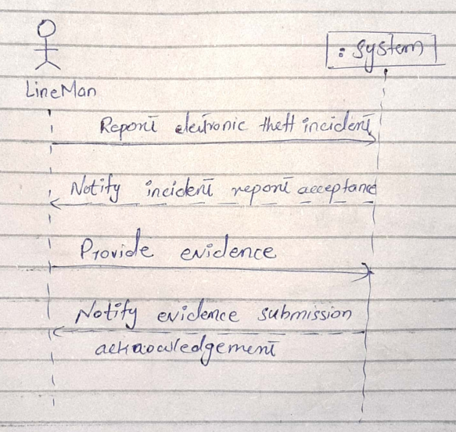

# Main Success scenarios:

1. Line man successfully reports an electronic theft incident to the Electronic Theft Detection System.
2. Incident report is generated, submitted to the court, and accepted as valid evidence.
3. Line man gathers relevant evidence related to the incident.
4. Line man provides the gathered evidence to the Electronic Theft Detection System.
5. Electronic Theft Detection System submits the evidence to the court.
6. Court acknowledges the submission of evidence.
7. Line man is notified about the court's acknowledgement of the evidence submission.

# System Sequence Diagram:

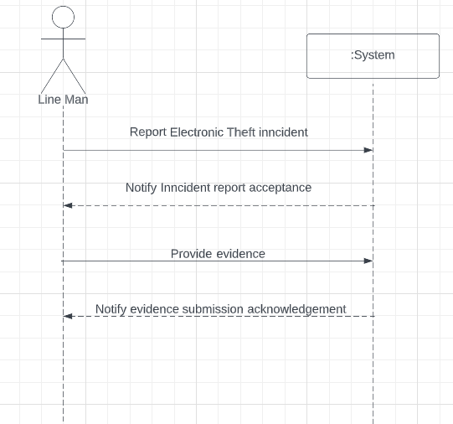

# Prototypes:

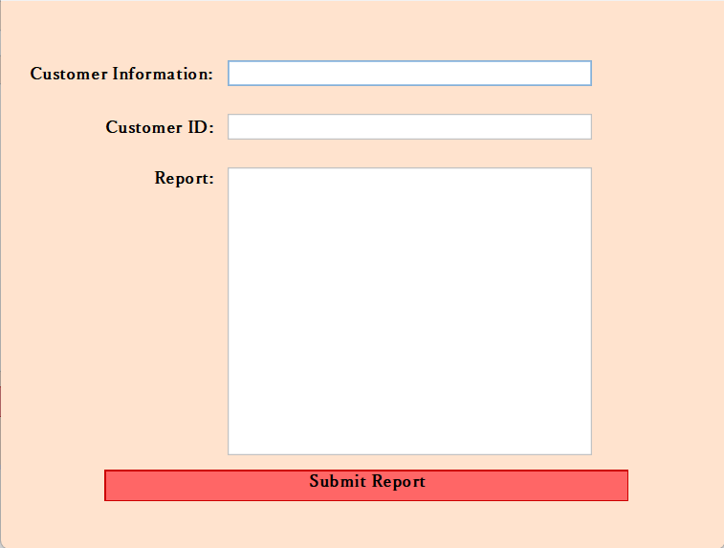This is the main interface where line man enters the reports details.

System sends notification to accept report.

